Health and Safety Policy

# Health and safety aim

We specialise in the production and installation of steel fabrications for the construction industry. We recognise that health and safety risks associated with working in engineering workshops and on construction sites are significant, often involving high-risk activity.

Accordingly, we aim to provide safe and healthy working conditions that prevent work-related injury and illness. We do this by always maintaining sound systems for:

* carrying out risk assessments
* applying effective preventive measures and controls
* promoting a pro-active safety culture

# Commitment to health and safety management

We achieve this by ensuring that our management system complies with the requirements of the Standard AS/NZS ISO 45001:2018 Occupational health and safety management systems.

Our commitment is to maintain certification to this Standard and to continually improve the effectiveness of the processes that support it.

# Health and safety objectives

As far as is reasonably practicable, our objectives are to minimise short- and long-term risks of injury or illness by setting health and safety objectives consistent with the following framework:

* By clearly identifying risks specifically associated with our activities.
* By eliminating risks where possible and minimising them if not.
* By setting measurable targets to continually improve health and safety performance.
* If an injury to an employee occurs, by working with them and health practitioners to provide rehabilitative care and a return to work as soon as possible.
* By complying with all applicable legislative and regulatory requirements.
* By actively promoting the participation of workers, and consulting with them, on all matters that potentially impact their health and safety.

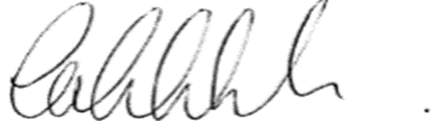

Caleb Jackson

Director  
January 31st, 2022